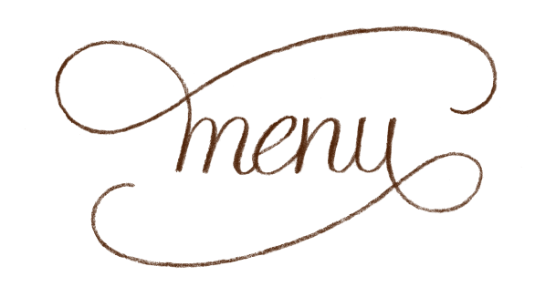
Ghillie Bar & Lounge
Some Thing for the Table:
Bread basket, olive oil, balsamic £4..50

Small Plate’s (Hot)
Tiger prawns, chorizo, smoked paprika, garlic, olive oil £7.50

Baked camembert, garlic, thyme £6.50

Soup of the Day, Sourdough £5.00

Chorizo link, potato, garlic £6.00

Lightly dusted calamari, tartare, £6.50

Portabella mushroom, blue cheese £6.50

Small Plate’s (Cold)
Chick pea hummus & Pitta £5.50

Olives, garlic & feta £5.50

Sorento ham, chorizo & salami £6.00

Taramasalta & pitta bread £5.50

Local cured salmon, caper berries, red onion, brown bread £7.50

Heritage tomato, pesto, creamed goats’ cheese, rocket £6.00
All small plate’s
For 3 £18.00 For 5 £25.00
From 12.00 - 14.30 / 18.00 -21.00
Main’s

Homemade burger, Beef or spiced Chicken, brioche roll, Chorizo, burger sauce, smoked cheese, lettuce, tomato, onion rings, skinny fries £12.50

Beer battered cod, chips, mushy peas, tartare sauce, lemon £12.00

Vegetable curry, rice, bok choi coriander & chilli £11.50
Add Chicken £13 Add Tiger Prawn £15

Local pan seared catch of the day, wild mushroom, borlotti bean & spinach fricassee £14.50

Homemade mushroom & halloumi burger, brioche roll, burger sauce smoked cheese, lettuce, tomato, onion rings, skinny fries £12.00

Chicken Coq au vin: (with a twist) Button onions, pancetta, wild mushroom, white wine & Cream, Potato puree £13.50

Butcher’s Cut (10oz) portabella mushroom, tomato, onion rings, chips, peppercorn or blue cheese sauce £ M.P

Grilled Gammon, eggs, tomato, mushroom, peas, chips £12.50

Please ask staff about daily specials & desserts

